VULKAN API

Vulkan API #1 Начальная установка и настройка
https://www.youtube.com/watch?v=CxFsM04jOcQ

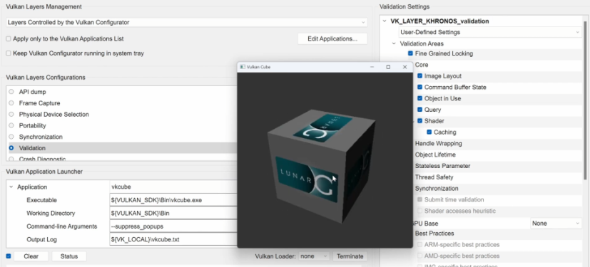

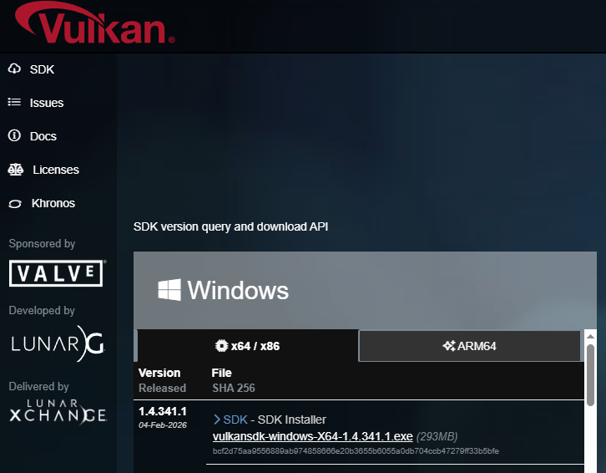

Download MSYS2: https://www.msys2.org/#installation
Download Vulkan SDK: https://vulkan.lunarg.com/sdk/home#windows
Download Visual Studio Code: https://code.visualstudio.com/

RUN: C:\msys64\clang64.exe

pacman -S mingw-w64-clang-x86_64-clang
pacman -S mingw-w64-clang-x86_64-gdb
pacman -S mingw-w64-clang-x86_64-glfw

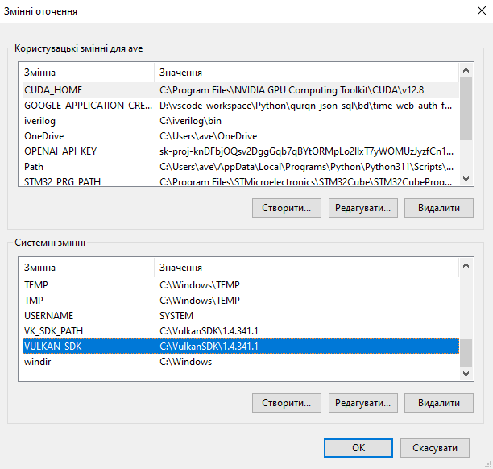
path
C:\VulkanSDK\1.4.341.1\Bin
C:\msys64\clang64\bin
VK_SDK_PATH
C:\VulkanSDK\1.4.341.1

VULKAN_SDK
C:\VulkanSDK\1.4.341.1

MSYS2_CLANG64_PATH
C:\msys64\clang64\bin

Reboot

cmd

echo %VULKAN_SDK%
C:\VulkanSDK\1.4.341.1

echo %MSYS2_CLANG64_PATH%
C:\msys64\clang64

clang --version
clang version 19.1.4
Target: x86_64-w64-windows-gnu
Thread model: posix
InstalledDir: C:/msys64/clang64/bin

gdb --version
GNU gdb (GDB) 15.2
Copyright (C) 2024 Free Software Foundation, Inc.
License GPLv3+: GNU GPL version 3 or later <http://gnu.org/licenses/gpl.html>
This is free software: you are free to change and redistribute it.
There is NO WARRANTY, to the extent permitted by law.

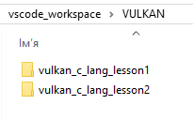

https://github.com/ingram12/vulkan_c_lang_lesson

Vulkan API #8 Создание GraphicsPipline, CommandBuffers, SyncObjects
(8:27)
https://youtu.be/BqeEEOBPJ9w?si=CI8T35MHiPfJcl2u&t=507

C:\VulkanSDK\1.4.341.1\Bin\glslc.exe shaders\shader.vert -o shaders\vert.spv
C:\VulkanSDK\1.4.341.1\Bin\glslc.exe shaders\shader.frag -o shaders\frag.spv

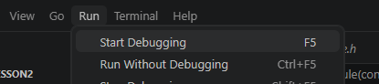

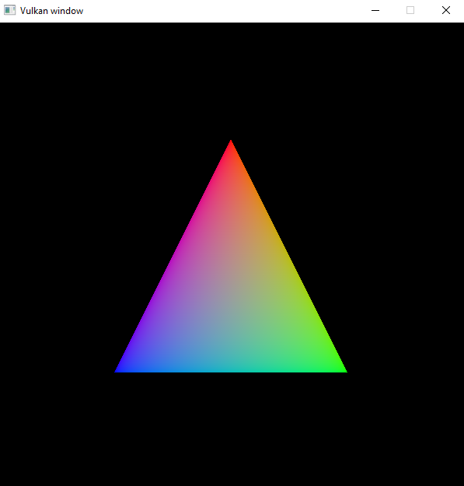
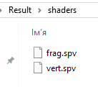
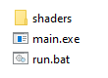

Android Studio NDK C/C++ VULKAN APP
https://chatgpt.com/share/69d188c0-61c4-8326-914e-f20cb1421c0d

Vulkan compute-only шаблон
https://chatgpt.com/share/69d19755-dfb0-8333-a646-0b79f4848b67

C:\VulkanSDK\1.4.341.1\Bin\glslc.exe shaders\comp.comp -o shaders\comp.spv

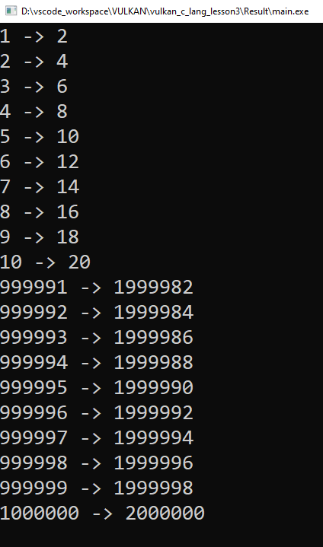

How to run Vulkan samples on Android Emulator
https://www.youtube.com/watch?v=4lEby4PUMUQ

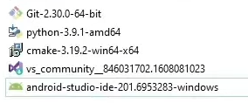

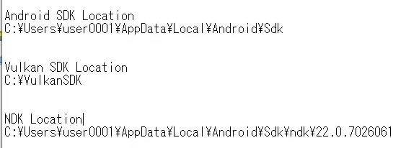

Vulkan graphics API
https://developer.android.com/ndk/guides/graphics/index.html
https://developer.android.com/ndk/guides/graphics/getting-started
https://github.com/KhronosGroup/Vulkan-Samples/

